……….
30723 Sodaville Rd Lebanon, Oregon
January 2018 Volume 1, Issue 18

City Hall (541) 258-8882 Mayor Suzie Hibbert email: sodaville@cityofsodaville.org
Web Address: www.sodaville.org Judy Smith – City Administrator
000000000000…………..000000000000000000000000000000

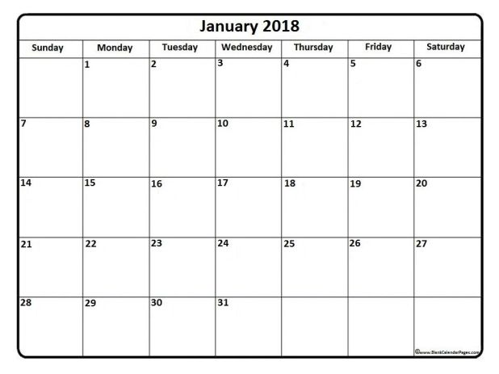
City Council Meeting City Hall Hours
7:00 pm January 18, 2018 Mon.–Thurs. 10 am–2 pm
CITY UPDATE

CITY HALL & PUBLIC WORKS WILL BE CLOSED Monday, JANUARY 15, 2018

With the start of the New Year, there is not much to report or update on. As I said in the last newsletter, this time of year is for playing catch up, filing taxes, updating information, etc. I will be working on getting bid packages together for the new park once all of the ideas from the Citizen Planning Committee are brought to me. So, if you have any ideas or requirements for the park, please attend the meeting. The Mayor has listed the details below.

Speaking of updating information, if you have a new telephone number or email address, please let me know as soon as you can. The City needs the information in case of emergency. If you have a major leak when you are not home and Stan has to turn off your water, I would like to be able to get ahold of you as soon as possible. No one likes to be without water.

Judy Smith, City Administrator

MAYOR’S MESSAGE

It's another year already, 2018 arrived with a boom! And sparkles. The city was once again treated to a fantastic display of fireworks just after midnight. What a fun way to greet the New Year. Thank you to Ray Jackman and The Road Maggots.

You can see from Judy's news and Stan's report what is going on in the city. I'll leave it to them to inform

I'm going to talk about the fun stuff. The Citizen's Planning Committee is beginning the New Year with new people at the head, fresh new ideas, more projects and GIFT CARDS. Show up and see if you will win something fun! We will also be having the fan favorite food of Pizza. Meeting starts at 6 pm, 3rd Thursday of the month. City Council meeting follows @ 7pm. You are welcome to stay; we'd love to have you. Or leave to go finish up your evening. Either way, come visit us for dinner, entertainment, information of what's going on around you and a chance to win a prize! January 18, 2018 @ 6 pm City Hall. I do want to point out that the Citizen's Planning Committee last 2 years worked hard, did a great job and gave it their all! Sad to say, some of them have moved out of town, and others job schedule changed. Hopefully some of them will still join us. It's also your turn. I'm taking my turn of being Mayor. It's your turn to be a part of the Citizen's Planning Committee.

See you around!
Mayor Suzie Hibbert mayorhibbert@gmail.com

Public Works Newsletter

Are you Prepared for an Emergency?

Everyone should have an emergency plan in place and be prepared to take care of themselves for at least the first 72 hours after a disaster. Preparing for and responding to disasters begins with preparing yourself and your family. When a large disaster strikes and first responders are overwhelmed the first people you will turn to for help are your neighbors. Consider building good relationships with your neighbors now so you can work together with them in times of need.

Four Simple Steps to Consider

1. Maintain a kit of emergency supplies.
Emergency supplies should include; Important documents, bedding and shelter, food and water, medications and personal supplies and clothing.

2. Make a plan of what you will do.
If needed, know where emergency shelters are. Linn County and its incorporated Cities have been working on a shelter plan for several years. Many of the Churches and Schools in the area would be used for sheltering residents of the area. Linn Counties website has additional information you should be familiar with to make a plan work.

3. Inform yourself of potential disasters.
Stay informed. Some disasters like extreme cold, hurricanes or strong winds are predictable and statements by weather services will let you know. Others like earthquakes are less predictable but should be considered when making a plan.

4. Help get your community prepared.
Share your knowledge with your neighbors and friends in the community. Once your knowledge is shared ask your friends to share with their friends in the community.

As we have all seen there are many different disasters that have happened around the world recently. It is everyone’s responsibility to prepare for what may come!

Stan Smith, Public Works Director

Country Girl Quilting
*Long-arm Machine Quilting

Call Sharon Hill and Joleana Altom at 541-401-7936
Carries Country Inn Adult Foster Home

is located at 30785 Washington Street in Sodaville.
“A safe, comfortable home where you can keep your
dignity, respect and independence.”
ha
For information call: 541-570-1430

If you have any announcements, information or ads you wish to have published in the newsletter, please call before the 6th of the month and I will be happy to insert them!
“The City of Sodaville is an equal opportunity provider and employer.”

